**Grievance App**

**Bachelor of Engineering**

**in**

**Electronics and Communication Engineering**

**By**

1. **Philip James [ Team Lead ]**
2. **Nishanth R**
3. **Mohammad Aathil A**
4. **Loga Prabakar V S**
5. **Shrujan Karthick V**

**Under the guidance of**

**Ms. Pavithra (CONCENSUS)**

**Department of Electronics and Communication Engineering**

**Sri Eshwar College of Engineering Coimbatore,**

Tamil Nadu - 641202

**ABSTRACT**

**The Grievance App is a user-friendly web application designed to streamline the process of filing and tracking complaints related to essential services for Hostel and PGs . It enables users to submit grievances under different categories, such as Plumbing Complaints, Electricity Complaints, and Other Complaints, with an easy-to-use interface. The application ensures efficient communication between users and the concerned authorities, enhancing transparency and responsiveness. Additionally, users can check the status of their complaints, promoting accountability and prompt resolution. Developed using React.js, the app offers a seamless and intuitive experience, making grievance redressal more accessible and effective.**

**OVERVIEW**

The **Grievance App** is a web-based platform designed to simplify complaint registration and tracking for **Hostel and PG residents**. Built using React.js, the app offers a smooth and user-friendly experience, allowing residents to report issues under categories like **Plumbing, Electricity, and Other Complaints**.

By enabling **efficient communication** between users and the relevant authorities, the application ensures that grievances are addressed with transparency and accountability. Residents can also monitor the progress of their complaints in real-time, keeping them informed throughout the resolution process.

With a focus on **quick and effective issue resolution**, the app enhances responsiveness and encourages prompt action from authorities. Its intuitive design makes it accessible to all users, streamlining the grievance redressal system.

By improving efficiency and reliability, the Grievance App contributes to a **better living environment** in hostels and PG accommodations.

**CODE**

**import { useState } from "react";**

**import { useNavigate } from "react-router-dom";**

**import "../styles/AuthForm.css";**

**export default function AuthForm() {**

**const navigate = useNavigate();**

**const [isLogin, setIsLogin] = useState(true);**

**const [formData, setFormData] = useState({**

**email: '',**

**password: ''**

**});**

**const [error, setError] = useState('');**

**const handleChange = (e) => {**

**const { name, value } = e.target;**

**setFormData(prev => ({**

**...prev,**

**[name]: value**

**}));**

**};**

**const handleSubmit = async (e) => {**

**e.preventDefault();**

**setError('');**

**try {**

**const response = await fetch('http://localhost:5000/api/login', {**

**method: 'POST',**

**headers: {**

**'Content-Type': 'application/json',**

**},**

**body: JSON.stringify(formData),**

**});**

**const data = await response.json();**

**if (data.success) {**

**navigate('/complaint');**

**} else {**

**setError('Invalid email or password');**

**}**

**} catch (error) {**

**setError('Server error. Please try again.');**

**}**

**};**

**return (**

**<div className="container">**

**<div className="form-box">**

**<h2>{isLogin ? "Login" : "Change Password"}</h2>**

**{error && <div className="error-message">{error}</div>}**

**<form onSubmit={handleSubmit}>**

**<input**

**type="email"**

**name="email"**

**value={formData.email}**

**onChange={handleChange}**

**placeholder="Email"**

**required**

**/>**

**<input**

**type="password"**

**name="password"**

**value={formData.password}**

**onChange={handleChange}**

**placeholder="Password"**

**required**

**/>**

**{!isLogin && <input type="password" placeholder="Confirm New Password" required />}**

**<button type="submit">{isLogin ? "Login" : "Change Password"}</button>**

**</form>**

**<p>**

**{isLogin ? "Forgot your password?" : "Remembered your password?"}**

**<span onClick={() => setIsLogin(!isLogin)}>**

**{isLogin ? " Change Password" : " Login"}**

**</span>**

**</p>**

**</div>**

**</div>**

**);**

**}**

**import { useState } from "react";**

**import { useNavigate } from "react-router-dom";**

**import "../styles/ComplaintForm.css";**

**export default function ComplaintForm() {**

**const navigate = useNavigate();**

**const [complaint, setComplaint] = useState({**

**plumbing: false,**

**electricity: false,**

**other: false,**

**details: ""**

**});**

**const [submittedId, setSubmittedId] = useState(null);**

**const handleChange = (e) => {**

**const { name, type, checked, value } = e.target;**

**setComplaint((prev) => ({**

**...prev,**

**[name]: type === "checkbox" ? checked : value**

**}));**

**};**

**const generateComplaintId = () => {**

**const timestamp = Date.now();**

**const random = Math.floor(Math.random() * 1000);**

**return COMP${timestamp}${random}.slice(-12);**

**};**

**const handleSubmit = (e) => {**

**e.preventDefault();**

**const complaintId = generateComplaintId();**

**setSubmittedId(complaintId);**

**console.log("Complaint Submitted:", { ...complaint, id: complaintId });**

**};**

**const checkStatus = () => {**

**navigate('/status');**

**};**

**return (**

**<div className="container">**

**<div className="form-box">**

**<h2>Complaint Management System</h2>**

**<form onSubmit={handleSubmit}>**

**<label>**

**<input type="checkbox" name="plumbing" checked={complaint.plumbing} onChange={handleChange} />**

**Plumbing Complaints**

**</label>**

**<label>**

**<input type="checkbox" name="electricity" checked={complaint.electricity} onChange={handleChange} />**

**Electricity Complaints**

**</label>**

**<label>**

**<input type="checkbox" name="other" checked={complaint.other} onChange={handleChange} />**

**Other Complaints**

**</label>**

**<textarea**

**name="details"**

**placeholder="Describe your complaint..."**

**value={complaint.details}**

**onChange={handleChange}**

**required**

**></textarea>**

**<div className="button-group">**

**<button type="submit">Submit Complaint</button>**

**<button type="button" onClick={checkStatus} className="status-button">Check Status</button>**

**</div>**

**</form>**

**{submittedId && (**

**<div className="submission-success">**

**<h3>Complaint Submitted Successfully!</h3>**

**<p>Your Complaint ID: <span className="complaint-id">{submittedId}</span></p>**

**<p className="save-id-message">Please save this ID to check your complaint status later.</p>**

**</div>**

**)}**

**</div>**

**</div>**

**);**

**}**

**import { useState } from 'react';**

**import '../styles/ComplaintStatus.css';**

**export default function ComplaintStatus() {**

**const [complaintId, setComplaintId] = useState('');**

**const [status, setStatus] = useState(null);**

**const handleSubmit = (e) => {**

**e.preventDefault();**

**// Mock status check - this would typically fetch from a backend**

**setStatus({**

**id: complaintId,**

**status: 'In Progress',**

**submittedDate: '2024-01-30',**

**lastUpdated: '2024-01-30'**

**});**

**};**

**return (**

**<div className="status-container">**

**<div className="status-box">**

**<h2>Check Complaint Status</h2>**

**<form onSubmit={handleSubmit}>**

**<div className="input-group">**

**<input**

**type="text"**

**value={complaintId}**

**onChange={(e) => setComplaintId(e.target.value)}**

**placeholder="Enter Complaint ID"**

**required**

**/>**

**<button type="submit">Check Status</button>**

**</div>**

**</form>**

**{status && (**

**<div className="status-details">**

**<h3>Complaint Details</h3>**

**<div className="detail-item">**

**<span>Complaint ID:</span>**

**<span>{status.id}</span>**

**</div>**

**<div className="detail-item">**

**<span>Status:</span>**

**<span className="status-badge">{status.status}</span>**

**</div>**

**<div className="detail-item">**

**<span>Submitted Date:</span>**

**<span>{status.submittedDate}</span>**

**</div>**

**<div className="detail-item">**

**<span>Last Updated:</span>**

**<span>{status.lastUpdated}</span>**

**</div>**

**</div>**

**)}**

**</div>**

**</div>**

**);**

**}**

**OUTPUT IMAGES**

1. **Login Page**

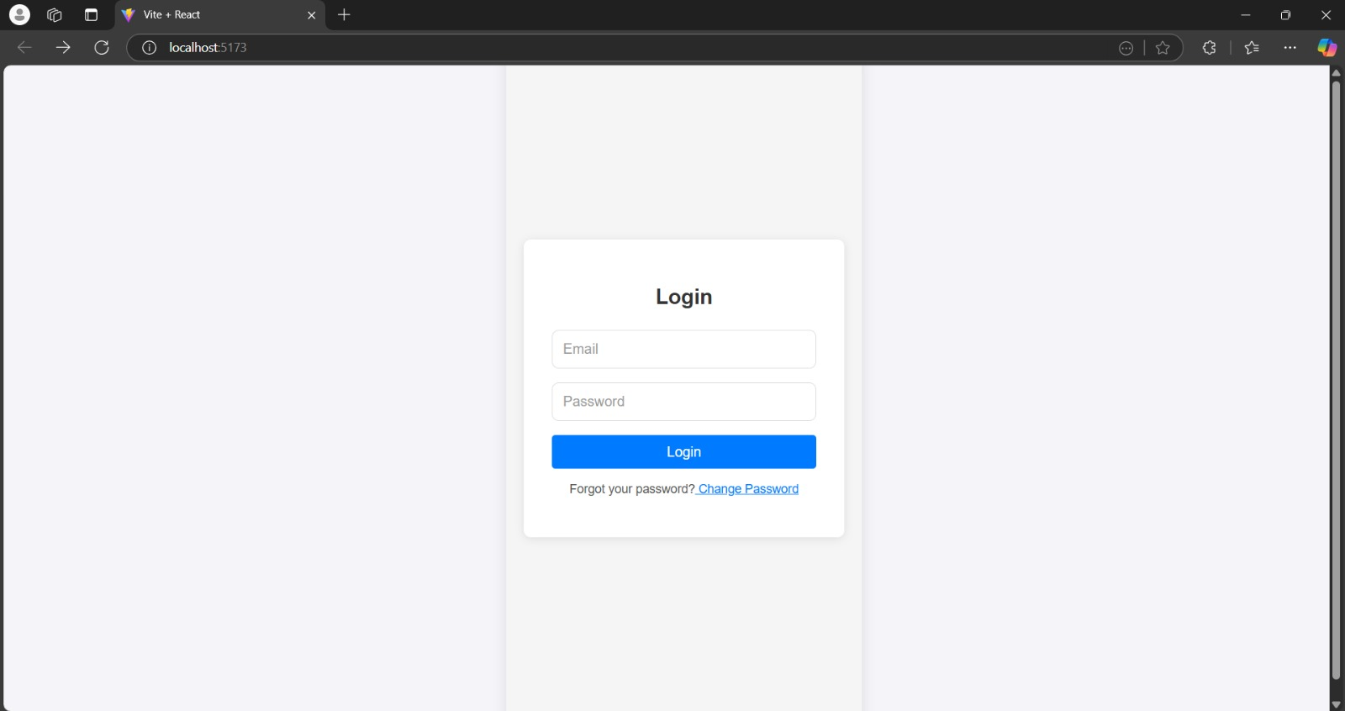

1. **Entering Password and Mail Id**

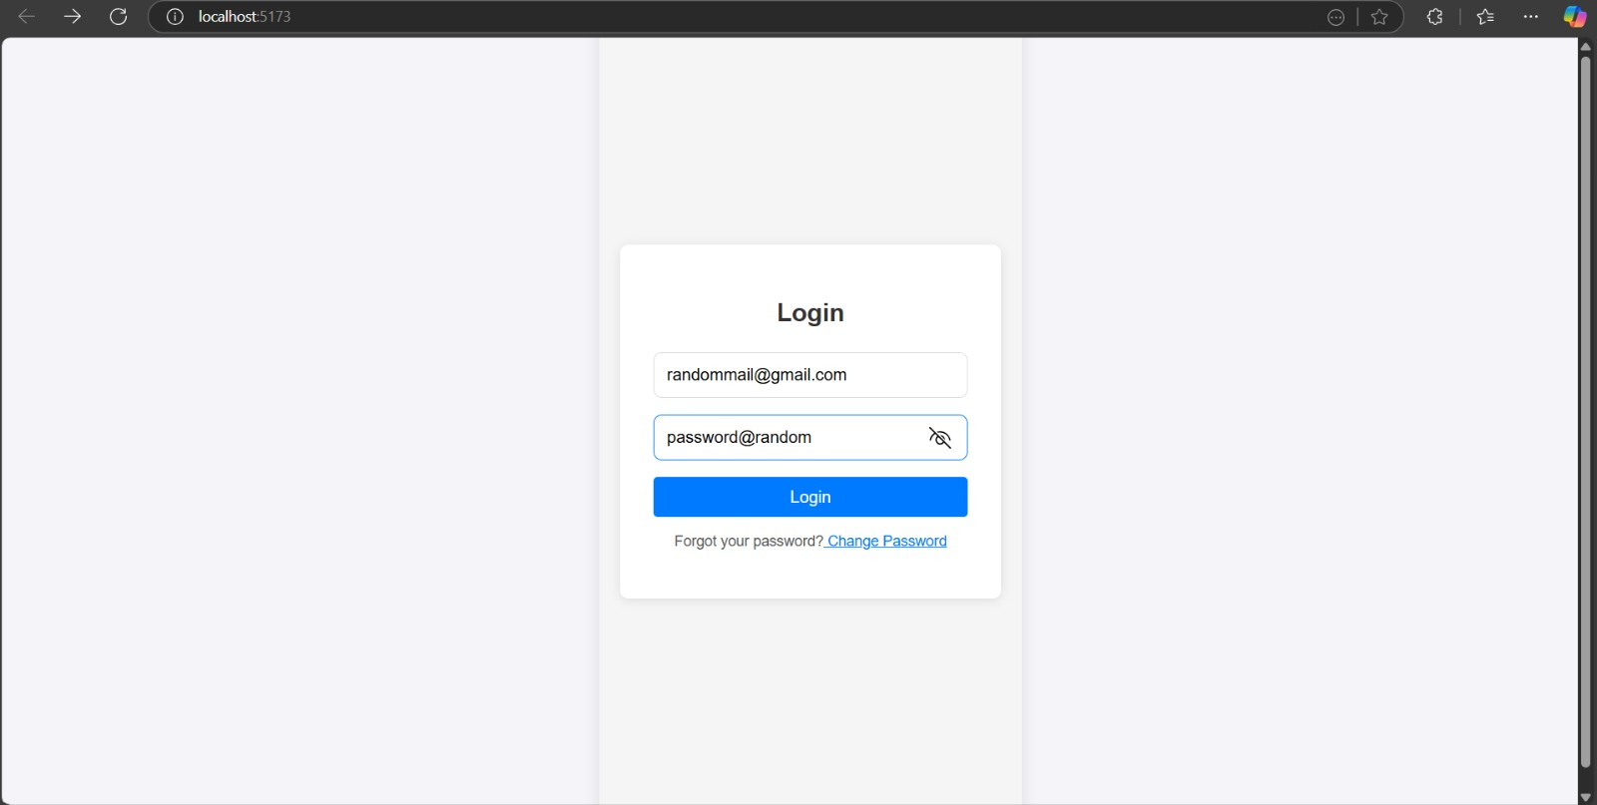

1. **Invalid Password or Mail Id**

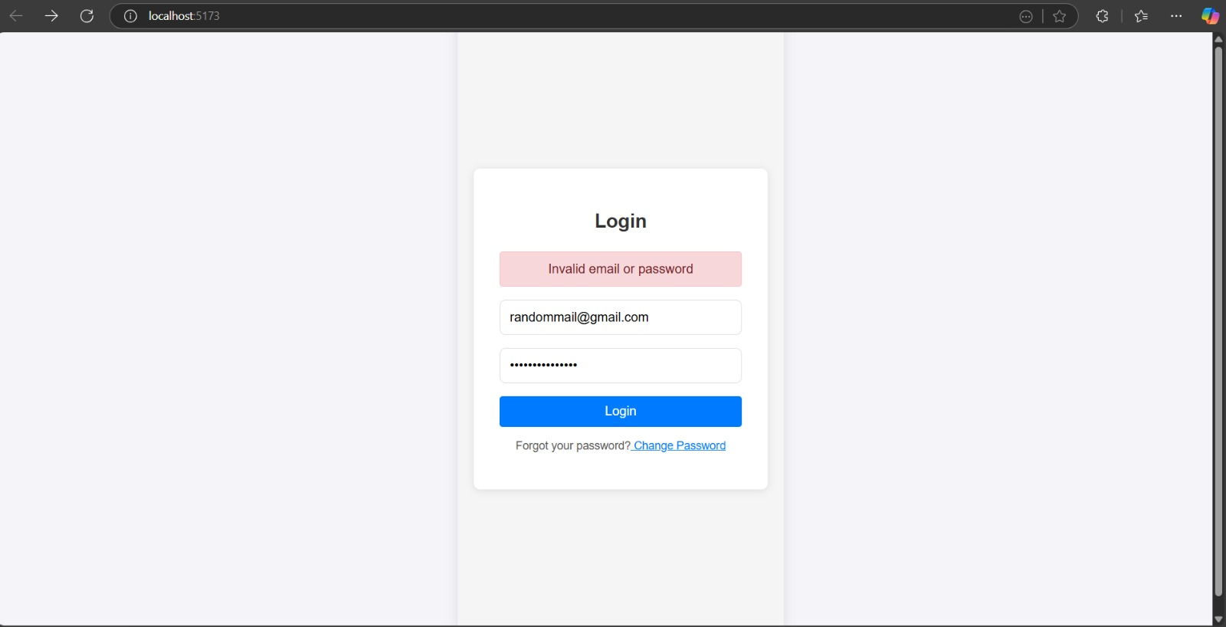

1. **Successful Login**

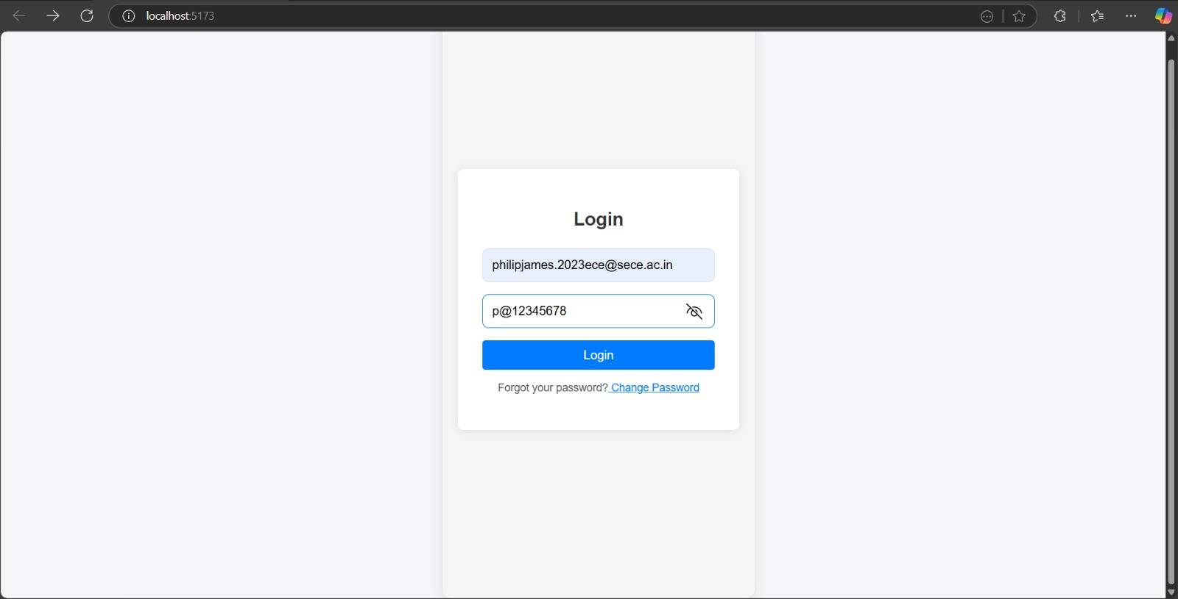

1. **Complaint Registration**

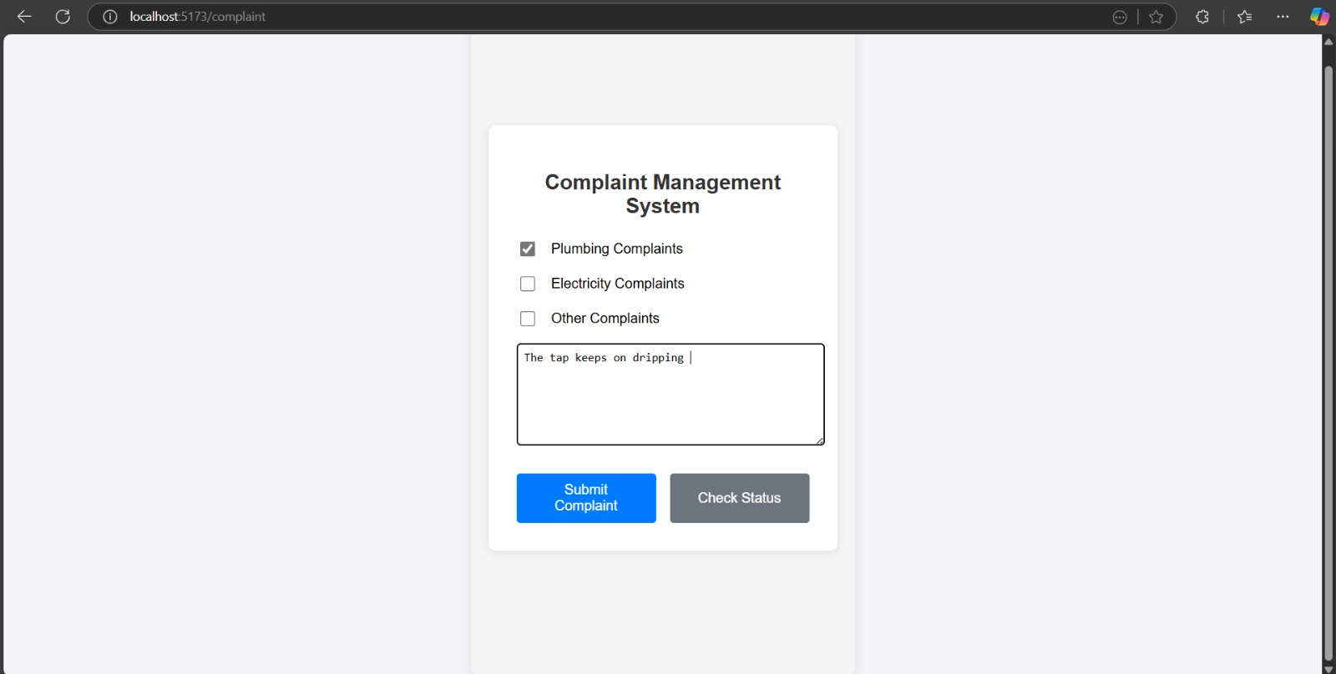

1. **Complaint Registered Successfully**

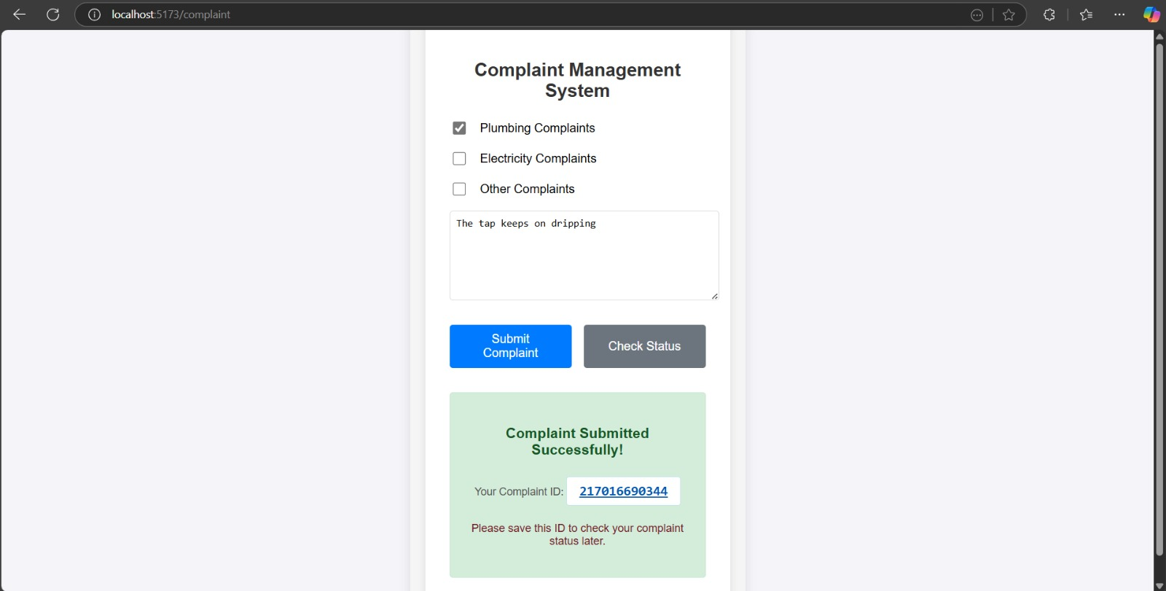

1. **Check Complaint Status Page**

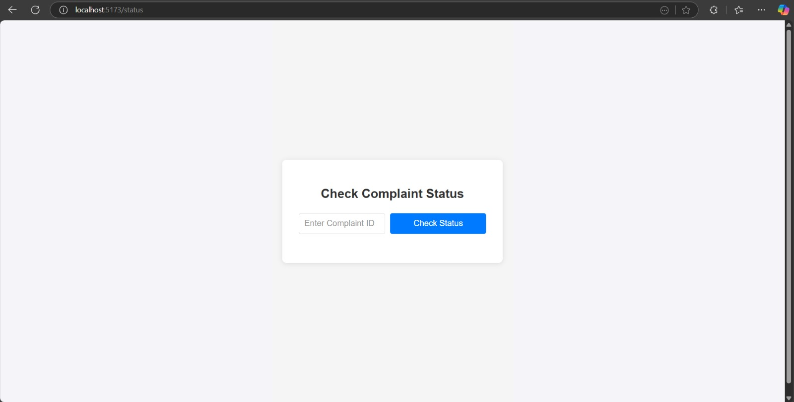

1. **Viewing Complaint Status**

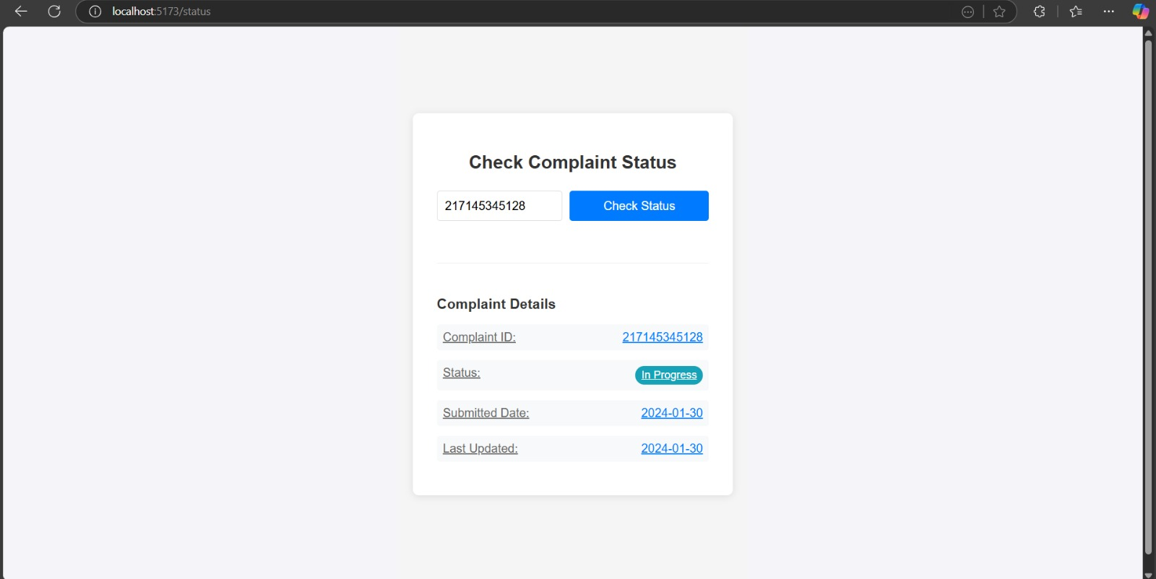

1. **Backend Package error**

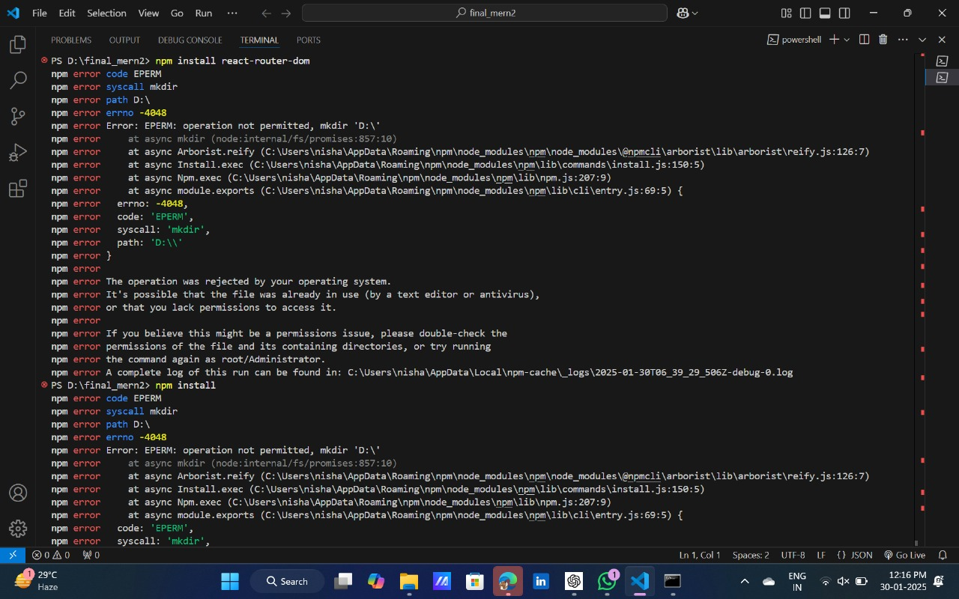

**Solved by : RUN AS ADMINISTATOR**

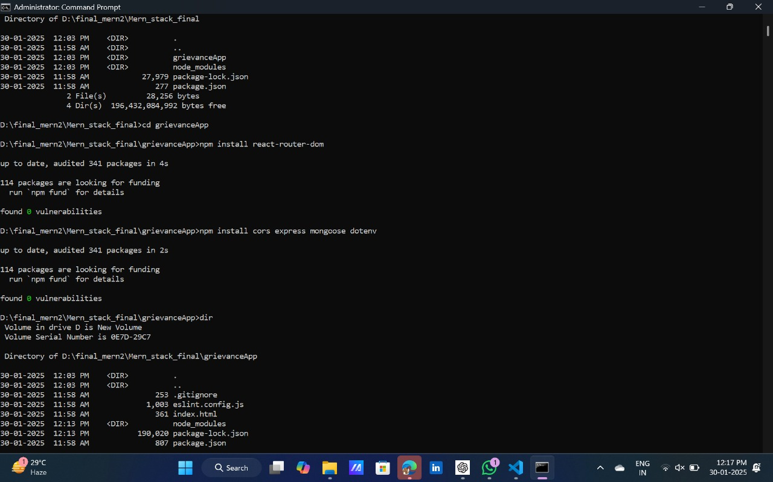

**REFERENCES**

1. [GeeksforGeeks | A computer science portal for geeks](https://www.geeksforgeeks.org/)
2. [ChatGPT](https://chatgpt.com/)
3. <https://www.anthropic.com/claude/sonnet>